(Approx. 210 words)

What is a Word Cloud?
By Dorothy Fitch, Editor, GVR Computer Club, AZ
April-Summer 2018 issue, Green Bytes
www.ccgvaz.org
newsletter (at) ccgvaz.org

A word cloud is a design made of words that you choose. There are several websites that will automatically create a design using the words you enter. All you need to do is type or paste in a list of words and click a button.

The size of each word depends on how many times that word is in the list. The more times the word is in the list, the larger it will appear. Depending on the word cloud generator you use, you may be able to change the angle of the words, pick different colors, and set other options.

I used this website for the General Meeting word cloud:
https://www.jasondavies.com/wordcloud/

This is the website I used for the Hot Peppers word cloud:
http://www.abcya.com/word_clouds.htm
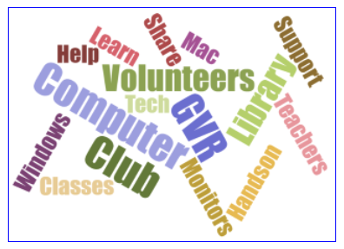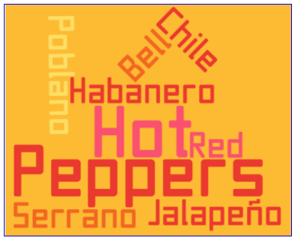

Just Google "word cloud" to find other websites to make your perfect word cloud.

It's fun to play around with word clouds. Give it a try. (If you are entering the names of grandchildren, however, don't type the name of any one of them more than the others, or it will appear larger. You don't want to be accused of favoritism, do you?)

